1 Business Case and Market Research

1.1 The problem: a fragmented follow-up journey
A typical outpatient episode is not a single visit but a chain of separate steps: an initial consultation, a diagnostic test (blood test, ECG or imaging), the release of the result hours or days later, finding a clinician to review it, and finally a follow-up decision. These steps often happen on different days and in different places. In the gaps between them the patient is on their own: symptoms may change, new questions arise, and uncertainty about what the result means accumulates.
What happens in these gaps is easily lost. Patients remember medical information poorly: a widely cited review reports that 40–80% of the medical information given by practitioners is forgotten immediately, and that almost half of what is remembered is incorrect [1]. When the follow-up appointment arrives, the history is often reconstructed from memory, and the short consultation time is partly spent recovering information that could have been recorded as it happened.
Unmet need. Patients need a simple way to preserve symptom changes, questions and uncertainty between a test and the next appointment, so that a licensed clinician can review them together with the result. This is the need Symptom Guide addresses.

1.2 Market context in Singapore
Singapore already has the digital foundations for such a tool, and several trends increase the demand for it.
- Patients can already see their results, but are told to interpret them with a doctor. The national HealthHub platform shows laboratory, radiology, histology and other reports from the National Electronic Health Record, together with discharge summaries [2]. It explicitly advises that laboratory reports "should be interpreted in consultation with your doctor", and some report types are released only after a minimum six-week delay so that patients can discuss them with their doctor first [2]. Access to results is solved; preparation for the conversation about them is not.
- An ageing population with more chronic conditions and follow-ups. The share of citizens aged 65 and above rose from 13.1% in 2015 to 20.7% in 2025, and is projected to reach about one in four (23.9%) by 2030 [3]. Older patients have more tests, more follow-up appointments and more difficulty keeping track of symptoms and questions between them; caregivers often manage this on their behalf.
- Remote and continuous care is established. Telemedicine is licensed under the Healthcare Services Act, and in April 2024 the Ministry of Health (MOH) reported that 19 providers offered telemedicine without physical premises [4]. Patients are increasingly used to digital touchpoints between visits.
- Primary care is moving towards a continuous relationship. Under Healthier SG, residents enrol with one family doctor as their first point of contact and develop a health plan with that doctor, with plans made digital on HealthHub [5]. A structured symptom summary fits this model of ongoing care rather than one-off visits.

1.3 Target users and value proposition
The primary users are adults waiting between a diagnostic test and a follow-up appointment, including older patients and the family members who help them. The secondary beneficiaries are the clinicians who receive a clearer starting point for the follow-up conversation. Table 1 summarises what changes for the patient.
Table 1. Value proposition across the follow-up journey.
Moment | Without support | With Symptom Guide
During the wait | Symptoms are remembered separately and inaccurately | Changes are recorded when they happen, as present, absent or uncertain
Before follow-up | Questions and uncertainty are easy to forget | Questions and the evidence behind them are kept in one place
At the appointment | The history starts again from memory | An organised, exportable summary gives the discussion a clearer starting point

The expected value is less uncertainty for the patient and a more structured, efficient follow-up conversation. The chatbot's targeted questions (Section 2.5) serve this goal: they prompt the patient to report the symptoms that matter most for the possible conditions, which a free-text diary would not capture. The ranked list of possible conditions is presented as material to discuss with a doctor, never as a diagnosis.

1.4 Competitive landscape and differentiation
Three groups of existing products address parts of this journey (Table 2). Consumer symptom checkers focus on self-diagnosis and triage before care is sought. Their accuracy is limited: an evaluation of 23 symptom checkers on 45 standardised vignettes found the correct diagnosis listed first in 34% of cases and within the top three in 51%, with appropriate triage advice in 57% [6]. Telemedicine services provide access to a clinician but do not help the patient organise information between contacts. Record portals such as HealthHub provide results but deliberately leave their interpretation to doctors.
Table 2. Positioning against existing product categories.
 | Symptom checkers | Telemedicine apps | Record portals | Symptom Guide
Main purpose | Self-diagnosis and triage | Remote consultation | Access to results and records | Preparation for follow-up
Patient can review and correct what was understood | Limited | Not applicable | Not applicable | Yes: editable symptom log
Keeps context across turns and sessions | Usually single session | Within a consultation | Not applicable | Yes: versioned sessions
Shows the basis of each output | Rarely | Not applicable | Not applicable | Yes: supporting symptoms, sources
Data stays on the user's device | Usually cloud-based | Cloud-based | Government cloud | Yes: local language model

Symptom Guide differentiates on three properties: the patient can correct the system, because the symptom log stays visible beside the conversation; the conversation keeps its context, across turns and page reloads; and knowledge-based answers show their basis, so users can see which reported symptoms and which knowledge-graph relations support each output. Running the language model locally adds a privacy advantage, as conversation text does not leave the user's computer.

1.5 Business model and adoption path
The most realistic route to adoption is business-to-business-to-consumer: clinics, polyclinics or telemedicine providers offer Symptom Guide to their patients between a test and the follow-up visit, and receive the exported summary at the appointment. The patient uses it free of charge; the provider pays a licence or subscription fee justified by shorter history-taking and better-prepared consultations. Alignment with Healthier SG health plans and HealthHub would be a longer-term integration option. Operating costs are low, because the language model runs on commodity hardware and the knowledge graph and recall model are static files; the main costs are clinical validation, content maintenance and regulatory work. A pilot with one clinic, measuring consultation time and clinician-rated summary usefulness, would be the first step.

1.6 Regulatory and risk considerations
Positioning matters for regulation. Singapore's Health Sciences Authority (HSA) regulates software whose intended use meets the definition of a medical device, and its guidelines treat software that provides information "to triage or identify early signs of a disease or condition" as driving clinical management, requiring clinical evidence [7]. Symptom Guide is therefore positioned as a preparation and record-keeping tool: it never presents a diagnosis, shows medication relations only as information to discuss with a doctor, and carries a disclaimer on every result. Any future claim of diagnostic or triage performance would require registration and clinical validation. Personal data handling must comply with the Personal Data Protection Act; local processing and pseudonymised logs reduce this risk. The main residual risks, analysed in Section 5, are missed red-flag symptoms and over-reliance on the ranked conditions.

2 System Design and Model

2.1 Design overview
The chatbot treats symptom triage as a sequential decision problem. At every turn it holds a probability distribution over diseases, asks the one question expected to separate the most likely candidates, and stops when the probability has concentrated on a short differential diagnosis. Figure 1 shows the resulting pipeline of six stages: language understanding, symptom state, disease recall, a stopping decision, either informed search (next question) or drug retrieval (final result), and reply generation.
Three principles shaped the design:
- The language model never makes clinical decisions. The large language model (LLM) only proposes symptom observations, which deterministic validators must confirm, and writes the conversational wording. Ranking, question choice, stopping and medication information are computed by inspectable components.
- Every output is traceable. Each candidate disease lists the user-confirmed symptoms that support it, each question carries the reason it was chosen, and each drug relation carries its relation type and knowledge source.
- Evidence has three states. A symptom is present, absent or unknown. "Not sure" is never converted into "absent", because absence is evidence while uncertainty is not.
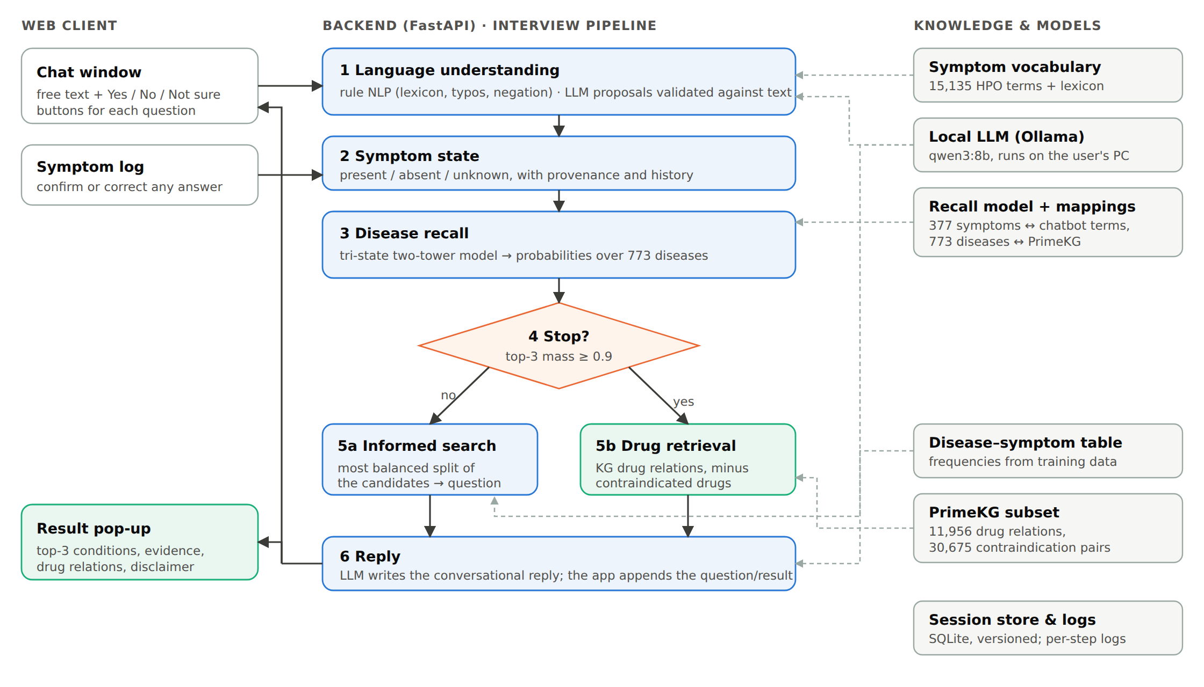
Figure 1. System architecture. Solid arrows show the interview loop; dashed arrows show which knowledge source each stage uses.

2.2 Medical knowledge graph
The knowledge graph is a subset of PrimeKG [8], which integrates 20 biomedical resources. We kept disease, phenotype and drug nodes and the relations between them, and removed node types without relevant links (for example anatomy). The preprocessed reasoning store contains 6,683 diseases with 142,704 disease–phenotype edges and 1,021 explicit "lacks phenotype" edges; 1,548 diseases with 11,956 drug relations (9,388 indications and 2,568 off-label uses) over 1,855 drugs; and 30,675 disease–drug contraindication pairs. The graph serves three purposes: its 15,135 phenotype terms, based on the Human Phenotype Ontology (HPO) [9], form the chatbot vocabulary; its drug relations and contraindications drive drug retrieval; and it powers the knowledge-graph reasoning baseline described in Section 2.8.

2.3 Disease recall model
Candidate diseases are produced by a tri-state two-tower retrieval model developed by team member Liu Hengyu. It was trained on a public Disease–Symptom dataset [10] of 246,945 records covering 773 disease labels and 377 binary symptoms. After exact duplicates were removed (189,647 records), the data were split 80/10/10 so that identical symptom vectors never cross splits (151,899 / 18,774 / 18,974 records).
The patient is encoded as a 754-dimensional vector: the first 377 entries mark symptoms reported present, the second 377 mark symptoms reported absent, and an unknown symptom is zero in both halves. A patient tower (a multilayer perceptron, 754 → 128 → 64) maps this vector to an embedding, which is scored against a learned 64-dimensional embedding of each disease:
score(d) = ⟨ f(x), e_d ⟩ / 8, p(d | x) = softmax(score)
On the held-out test split, with three present symptoms per case, the model reaches Hits@1 0.558, Hits@3 0.817, Hits@5 0.898, Hits@10 0.972 and MRR 0.704. For deployment we re-implemented the forward pass in NumPy, reading the same weight file, so the chatbot runs without PyTorch; the two implementations agree to within 10⁻⁵.

2.4 Linking the model to the knowledge graph
The model speaks in lay symptom labels (for example "sharp chest pain"), while the dialogue works with HPO terms (for example "Chest pain"). A generated mapping links the two using the knowledge-graph node attached to each model symptom (Table 3). Broad terms receive an asymmetric rule: a Yes to "Chest pain" is recorded as the group's representative symptom ("sharp chest pain"), while a No rules out every member of the group. In addition, 19 reviewed synonyms connect common colloquial terms to the model, for instance "Pharyngitis" (what users mean by "sore throat") to the model symptom "sore throat". On the output side, 291 of the 773 diseases are linked to a PrimeKG disease, 231 of which have drug relations.
Table 3. Mapping of the 377 model symptoms to the chatbot vocabulary.
Mapping type | Model symptoms | Example
Exact name match | 47 | cough → Cough
One-to-one through the shared graph node | 151 | coughing up sputum → Productive cough
Representative of a broad term | 19 | sharp chest pain ← Chest pain
Model-only term added to the vocabulary | 160 | diarrhea, toothache
Total | 377

2.5 Informed search
Questions are chosen by a greedy best-first heuristic. Let C be the current candidate set with model probabilities p(d), and S(d) the symptoms associated with disease d. S(d) is taken from the training data: a symptom belongs to a disease when at least 20% of that disease's records contain it (5,389 disease–symptom pairs; a median of 7 symptoms per disease). For every symptom s that has not been asked yet:
P_yes(s) = Σ_{d ∈ C, s ∈ S(d)} p(d) / Σ_{d ∈ C} p(d), h(s) = min( P_yes(s), 1 − P_yes(s) )
The symptom with the largest h(s), the most balanced split of the probability mass, is asked next, with ties broken alphabetically so that runs are reproducible. Whatever the answer, roughly half of the remaining probability mass is either supported or contradicted. Because the choice depends only on how evenly a question splits the candidates, the heuristic does not need to estimate how many diseases each answer would exclude. If the disease–symptom associations are treated as certain, maximising h(s) is equivalent to maximising the entropy of the expected answer, that is, the expected information gain of the question. A Yes or No answer is then written into the recall model input and the ranking is recomputed, so candidates are down-weighted rather than deleted. A "Not sure" answer is recorded as unknown, leaves the model input unchanged and marks the symptom as asked, and the next question is chosen in the same way. The question is shown together with its rationale, for example "5 of 10 candidates (52% of the ranking weight) have this symptom".

2.6 Stopping rule
The interview stops when the three most likely diseases together hold at least τ = 0.9 of the probability. The result is then presented as a three-item differential diagnosis together with drug relations. Otherwise at least four candidates are kept and the interview continues, up to 12 follow-up questions. Two further stop conditions cover the case where no question can still split the candidates and the case where no disease matches. Interviews that end without meeting the probability criterion are reported as inconclusive, without drug information and with advice to see a doctor. The threshold was selected experimentally (Section 4.3).

2.7 Dialogue layer and LLM
A locally hosted Qwen3-8B model [11], served by Ollama, keeps all conversation data on the user's computer. For understanding, the LLM receives the latest message and a short list of candidate concepts (vocabulary matches and retrieval hits) and returns JSON observations. Each observation must quote the user's words exactly, refer to a candidate concept, and be a personal assertion rather than a question or a statement about another person. Observations that fail validation are rejected, and plausible but unconfirmed interpretations are shown as suggestions for the user to confirm. For replies, the LLM writes a short answer and is instructed not to ask questions itself; the application appends the informed-search question with Yes / No / Not sure buttons. Button answers bypass the LLM entirely, which keeps the questioning loop deterministic and fast.

2.8 Alternative reasoning modes
The three reasoning services sit behind common interfaces (recall, search, drugs), so the reasoning back end can be switched by configuration. Two earlier modes are kept for comparison (Table 4).
Table 4. Reasoning modes implemented behind the same interfaces.
 | kg | ddxplus | recall773 (final)
Candidate ranking | Symptom overlap in PrimeKG, weighted by specificity (IDF) | Tri-state model trained on DDXPlus [12] | Tri-state model, 773 diseases
Disease coverage | 6,683 | 49 | 773
Effect of a "No" answer | Deletes the diseases that have the symptom | Soft: absent input channel | Soft: absent input channel
Stopping | ≤ 2 candidates | ≤ 2 candidates | Top-3 mass ≥ 0.9
Main limitation | No probabilities; graph annotations are incomplete | Narrow scope (respiratory and cardiac) | Synthetic training data

3 System Development and Implementation

3.1 Architecture and technology stack
The back end is written in Python with FastAPI and Pydantic. A single orchestrator, ChatbotService, owns the dialogue state and calls the three reasoning interfaces, so each reasoning mode is a separate, testable adapter. Sessions are stored in SQLite with a version number on every state (optimistic concurrency) and a request identifier on every call, so a retried request is replayed instead of being applied twice. The front end is a Vue 3 single-page application written in TypeScript, using Pinia for state, Element Plus for components and Vite for builds. The FastAPI server serves the front end itself, so the whole system starts with one command. The LLM runtime connects to Ollama with a fixed context window and a keep-alive period, which removed model reloads between turns.

3.2 Integrating the team's components
- Knowledge graph. A preprocessing script turns the filtered PrimeKG tables into a compressed reasoning store (disease–symptom, "lacks", drug and contraindication maps) that loads in about one second.
- Informed search and drug retrieval. The group's search and drug-retrieval modules are used unchanged behind the service interfaces. We added candidate weighting by model score and a contraindication filter, which removes a drug if it is contraindicated for any remaining candidate.
- Recall model. The model bundle is copied into the repository with checksum verification of all 30 files. Mapping tables and the disease–symptom frequency table are produced by scripts, so they can be regenerated when the model changes.

3.3 Robust language understanding
Rule-based extraction remains the first layer, because it is fast and explainable, and because the LLM's candidate list depends on it. It detects assertion status (present, absent, uncertain, another person, past) around every matched term. During development we added four improvements:
- a lay lexicon of 431 colloquial phrases for 101 terms ("the runs", "throwing up", "stuffy nose");
- one-edit typo tolerance restricted to 69 common symptom words, with an exclusion list of real English neighbours ("couch" is not "cough", "thirty" is not "thirsty"); every correction is shown to the user;
- informal negation such as "dont" and "havent";
- a stop-list of 65 HPO modifier terms ("Severe", "Chronic", "Left") that must not be recorded as symptoms.

3.4 User interface
The interface (Figure 2a) combines a chat window, Yes / No / Not sure buttons for each question, and a symptom log grouped by status, where any answer can be corrected and the result is recomputed. When the interview ends, a result pop-up (Figure 2b) presents the top-3 conditions with their supporting symptoms, drug relations grouped by condition, the user's answers and a disclaimer. Two usability defects found in testing were fixed: the interview stalled after the user confirmed a suggested symptom or made small talk. The pending question is now asked again in both cases. The whole session, including the answers and the result, can be exported as a summary to bring to the follow-up appointment (Section 1.3).
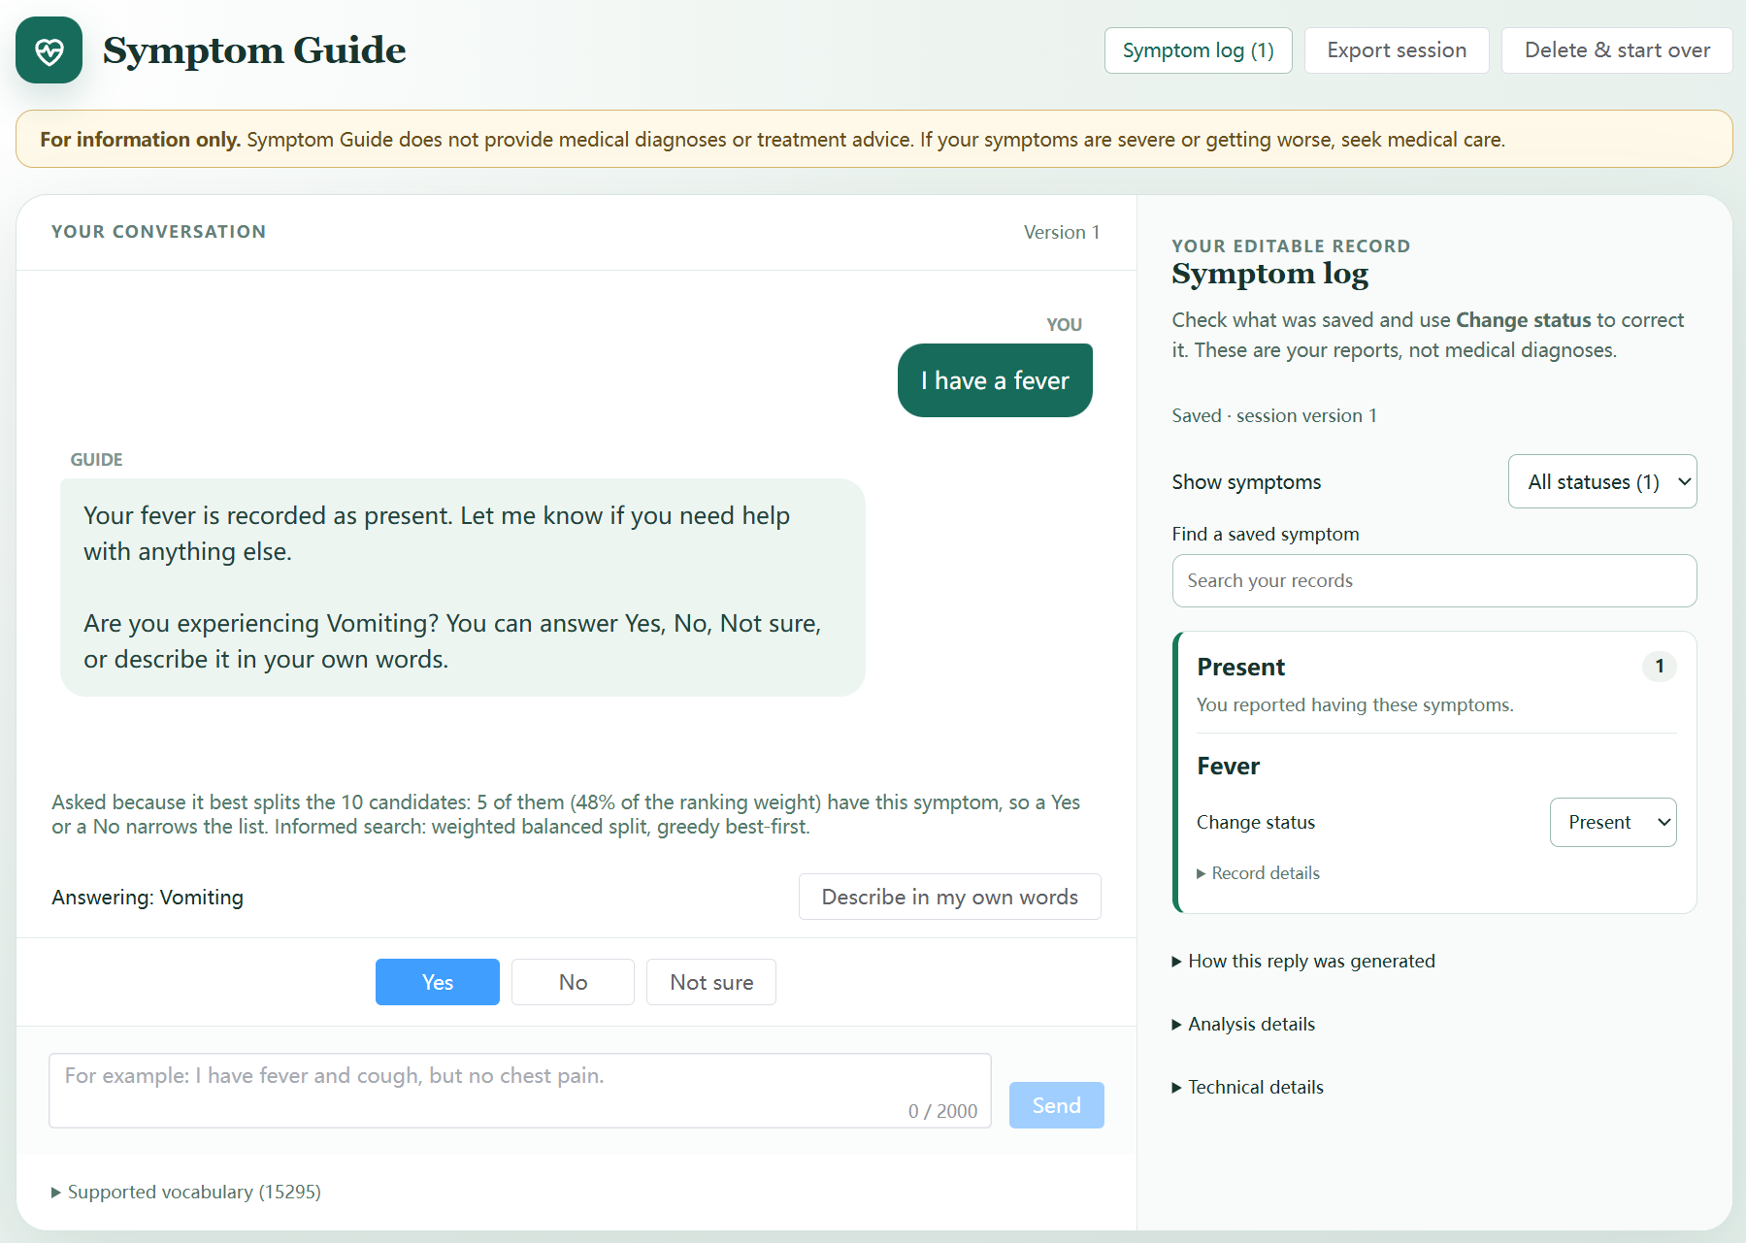
Figure 2a. Conversation view: the follow-up question with its rationale, Yes / No / Not sure buttons, and the editable symptom log.
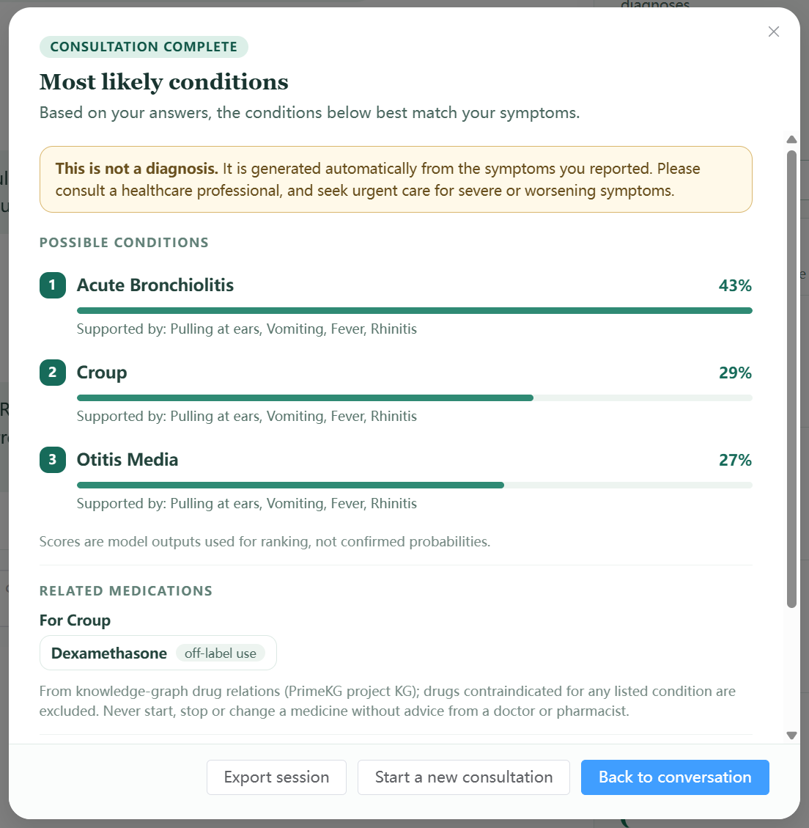
Figure 2b. Result pop-up after a converged interview: top-3 conditions with supporting symptoms, related drugs from the knowledge graph, and the disclaimer.

3.5 Observability, testing and reproducibility
Each pipeline stage writes structured log entries (startup, flow, NLP, agent, LLM, recall, search, drugs), so a single consultation can be traced from the user's words to the model input, the top-5 probabilities, the chosen question and the stopping decision. Logs carry a hash of the session identifier and do not record the user's raw text unless this is explicitly enabled. The back end has 234 automated tests, including 16 dedicated to the stopping rule. These cover configuration, exact boundary values (top-3 mass 0.900 versus 0.899), full sessions and the real model. Three evaluation scripts reproduce every number in Section 3, and the stop-rule validation fails with an error if accuracy or efficiency falls below fixed regression thresholds.

4 Experiments

4.1 Evaluation protocol
The experiments follow the five evaluation objectives defined at the start of the project: retrieval accuracy, questioning efficiency, robustness, explainability and overall task performance. Real patients could not be used, so interviews were run with a simulated patient. The patient opens with two symptoms and then answers each question Yes if the asked term covers one of its symptoms and No otherwise. Three test sets were used (Table 5).
Table 5. Test sets. D1 records come from the model's test split and were never used for training. The D2 patients' symptom lists were written independently of the model. The D3 blind probes were written by an independent agent that saw only the symptom list.
Test set | Size | Gold standard | Purpose
D1 Held-out records | 500 records, 256 diseases | Record label | In-distribution accuracy and efficiency; stop rule
D2 Clinical vignettes | 38 cases, 13 body systems | Diagnosis plus clinically acceptable alternatives | Out-of-distribution check; safety and explainability
D3 Language probes | 20 development, 20 held-out, 40 blind | Expected symptom and status | Robustness of language understanding

The main metrics are Hits@k (the correct disease is among the top k), "acceptable@3" for D2 (the diagnosis or an accepted alternative is in the top 3), the average number of follow-up questions, and the share of interviews ended by the stopping rule rather than by the 12-question limit.

4.2 Retrieval accuracy
Table 6 compares ranking after the opening message with ranking at the end of the interview. On D1 the interview raises Hits@3 from 59.0% to 85.4% and Hits@1 from 32.4% to 49.8%, with 5.0 questions on average. On the clinical vignettes, accuracy is much lower: the correct diagnosis is in the top 3 in 42.1% of cases, and a clinically acceptable diagnosis in 63.2%.
Table 6. Accuracy after the opening message (2 symptoms) and at the end of the interview.
Test set | Hits@1 (opening) | Hits@3 (opening) | Hits@1 (final) | Hits@3 (final)
D1 500 held-out records | 32.4% | 59.0% | 49.8% | 85.4%
D2 38 clinical vignettes | 5.3% | 13.2% | 13.2% | 42.1% (63.2% acceptable)
Reference: static ranking, 3 symptoms [model test set] | – | – | 55.8% | 81.7%

4.3 Choosing the stopping threshold
To compare stopping rules fairly, every D1 interview was first recorded for the full 12 questions. Each rule was then replayed on the same recordings (Table 7, Figure 3). Our first rule, which stopped only when the leading disease reached 0.80 and the top two reached 0.95, needed 7.5 questions on average. Rules based on the top-3 mass trade questions for accuracy smoothly. At τ = 0.9 Hits@3 equals that of the first rule (87.0%) with 2.5 fewer questions, and when the rule fires the correct disease is in the top 3 in 99% of interviews. We therefore adopted τ = 0.9. Run end to end with the deployed system, it gave 5.0 questions, 77.8% of interviews stopped by the rule and Hits@3 of 85.4%, close to the replayed values.
Table 7. Stopping rules replayed on the same 500 recorded interviews (D1).
Stopping rule | Avg questions | Stopped by rule | Hits@3 | Hits@3 when rule fired | Stopped although every answer was No
First rule (top-1 ≥ 0.8, top-1 + top-2 ≥ 0.95) | 7.5 | 62% | 87.0% | 99% | 14%
Top-3 mass ≥ 0.70 | 3.6 | 88% | 80.4% | 88% | 53%
Top-3 mass ≥ 0.80 | 4.4 | 85% | 83.6% | 93% | 44%
Top-3 mass ≥ 0.85 | 4.7 | 83% | 86.4% | 97% | 39%
Top-3 mass ≥ 0.90 (adopted) | 5.0 | 81% | 87.0% | 99% | 35%

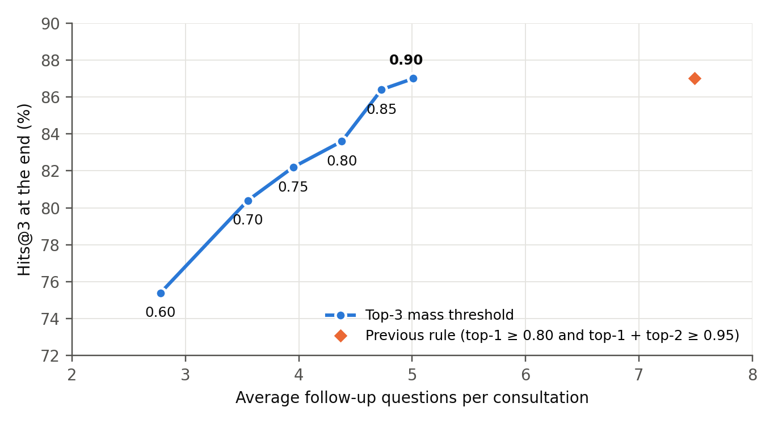
Figure 3. Accuracy against interview length for top-3 mass thresholds 0.60–0.90 on D1. The first rule needs 2.5 more questions for the same Hits@3.

4.4 Question selection
To measure the value of informed search, it was replaced by a baseline that asks a random question from the same pool of candidate symptoms; the baseline was run three times on D1. Informed search needed 9% fewer questions (5.0 against 5.5), ended more interviews through the stopping rule (77.8% against 70.7%) and improved Hits@3 by 3.3 points (85.4% against 82.1%). Hits@1 was, however, 3 points lower (49.8% against 52.9%; Figure 4).

4.5 Robustness to noisy and incomplete answers
Three perturbations were applied to D1 (Figure 4). When 30% of the answers were "Not sure", Hits@3 fell only from 85.4% to 81.2% and the interview grew by 0.8 questions. A single wrong answer to the first question was far more harmful: Hits@3 fell to 66.0%, and the stopping rule fired with only 75% precision, because the interview stopped early on misleading evidence. Opening with one symptom instead of two needed 9.1 questions and reached a Hits@3 of 67.2%.
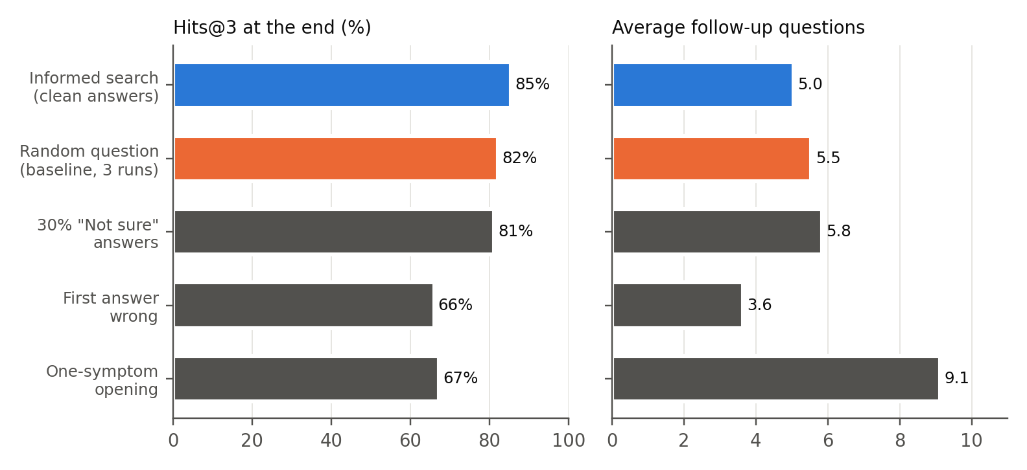
Figure 4. Question selection and answer noise on D1 (500 records): accuracy (left) and interview length (right). The random baseline is the mean of three runs.

4.6 Robustness of language understanding
On the 40 blind probes, the language-understanding changes of Section 3.3 raised the pass rate from 20% to 55% (Figure 5). Typos rose from 0/6 to 5/6, negation from 1/6 to 3/6 and colloquial wording from 0/14 to 4/14. The development probes, which guided the changes, rose from 45% to 100%, and the held-out probes from 20% to 90%; both figures are optimistic for that reason. End to end, the share of D2 vignettes whose correct diagnosis enters the candidate list after a natural-language opening rose from 28.9% to 47.4%. It now matches the rate obtained when the symptoms are entered as exact vocabulary terms. These results use the rule-based path; the LLM path was not evaluated quantitatively, because its outputs are not deterministic.
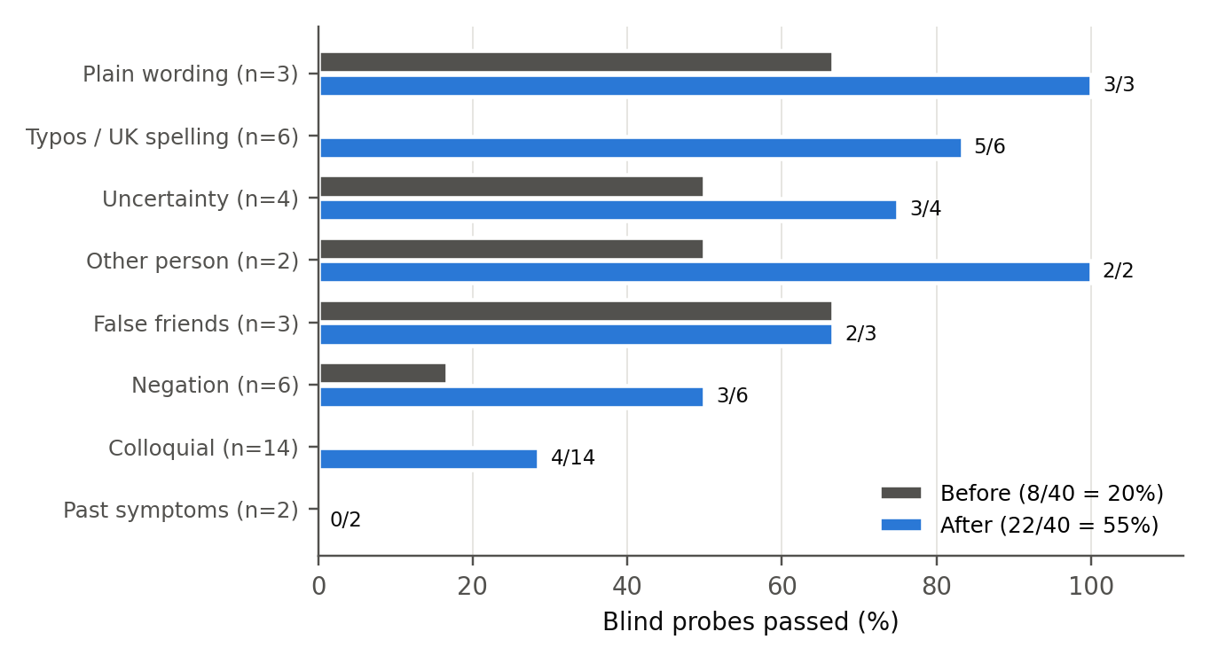
Figure 5. Blind language probes passed before and after the improvements, by type of input.

4.7 Explainability and safety
Automatic checks over all D2 sessions are summarised in Table 8. All explainability checks passed. The safety checks show two weaknesses: a recommendation for urgent care in red-flag cases, which is not implemented, and conclusions reached from denials alone.
Table 8. Explainability and safety checks.
Check (D2, 38 vignettes) | Result
Top candidate has at least one supporting, user-confirmed symptom | 100%
Every question shows the reason it was chosen | 100%
Every drug relation shows its relation type and source | 100%
Every result carries the "not a diagnosis" statement | 100%
No medication shown before the interview concludes | 100%
Recommended drugs contraindicated for a listed condition | 0 cases
Off-topic or symptom-free input produces no candidates | Pass
No confident result when the patient answers No to everything | 84%
Urgent-care advice in red-flag cases (heart attack, stroke, meningitis) | 0% (not implemented)

5 Findings and Discussion

5.1 Main findings
Asking questions is what makes the system accurate. With two opening symptoms, the model alone places the correct disease in the top 3 for 59% of D1 cases. After about five targeted questions this rises to 85%, which is higher than the static model given three symptoms (82%). The negative half of the input explains why. In static testing, adding up to five denied symptoms changed the model's Hits@1 by less than 0.3 points (0.558–0.560), whereas the denials collected during the interview, combined with targeted positive questions, account for much of the gain. Absence evidence is useful when it is gathered selectively, not when it is listed at random.
Top-3 probability mass is a reliable stopping signal. When the rule fired, the top 3 contained the correct disease in 99% of D1 interviews; when it did not, in only 36%. The way an interview ends therefore tells the user how confident the system is. This justifies presenting only converged results with medication information and labelling the others as inconclusive. Framing the output as a differential diagnosis rather than a single answer also matches how clinicians reason under uncertainty, and it was the change that made interviews finish in reasonable time.
Informed search helps, but less than expected. The balanced-split heuristic shortened interviews by 9% and improved Hits@3 by 3.3 points over random questions, but it did not improve Hits@1. The heuristic is myopic: it splits the candidates using a fixed disease–symptom table and does not ask the model how much each answer would change the ranking. A natural next step is to choose questions by expected information gain computed with the model itself, simulating a Yes and a No through the recall model for each candidate symptom.
Wrong answers cost far more than uncertain ones. Thirty percent "Not sure" answers cost 4 points of Hits@3, whereas a single wrong answer cost 19 points and made the stopping rule unreliable. In practice this argues for making "Not sure" an easy and clearly legitimate choice, and for asking for confirmation when one answer reverses the leading diagnosis. An aggregation scheme that treats answers as noisy observations rather than facts would also help.
Performance on realistic cases is much lower than on the training distribution. On the clinical vignettes the correct diagnosis reached the top 3 in 42% of cases (63% when clinically acceptable alternatives are counted), compared with 85% on held-out records. Cardiovascular (25%) and neurological (20%) cases were weakest. The training records are synthetic, so the model learns their regularities rather than clinical presentation. The 85% figure should therefore be read as an upper bound for this model, not as clinical accuracy.
Language understanding limits real use. The lexicon, typo tolerance and negation rules resolved most errors that follow a fixed pattern, but only 4 of 14 blind colloquial sentences were understood ("my head has been absolutely pounding", "wiped out") and neither past-symptom probe passed. Paraphrases of this kind are what the LLM path is intended to handle; measuring it reliably requires repeated runs and is left for future work.
Safety relies on deterministic guards, with one important gap. Disclaimers, medication shown only after a converged result, and contraindication filtering held in every test. However, the system does not recognise red-flag symptoms that require urgent care. Under the adopted threshold it can also conclude from denials alone: when the simulated patient answered No to every question, 35% of D1 interviews still ended through the stopping rule. Such results should at least be marked as based on limited evidence.

5.2 Limitations
- All evaluation used simulated patients, and the main dataset is synthetic. No clinician reviewed the outputs, and no real users were tested.
- The 38 clinical vignettes were written by the team, and the "acceptable" alternatives reflect the team's own judgement.
- Model probabilities are not calibrated, so the 0.9 threshold is an empirical setting rather than a 90% confidence level.
- Only 291 of the 773 diseases are linked to the knowledge graph, so medication information is unavailable for the rest.
- The LLM components are not deterministic and were evaluated only qualitatively.

5.3 Future work
- Add red-flag detection with explicit urgent-care advice, independent of the model.
- Choose questions by expected information gain using the recall model, and ask for confirmation when an answer changes the leading diagnosis.
- Calibrate the model (for example with temperature scaling on the validation split) so that thresholds have a probabilistic meaning.
- Retrain or fine-tune on clinically grounded data (for example DDXPlus-style patient simulations) and evaluate with clinician-written cases.
- Evaluate the LLM understanding path with repeated runs and add uncertainty-aware handling of conflicting answers.

References
[1] R. P. C. Kessels, "Patients' memory for medical information," Journal of the Royal Society of Medicine, vol. 96, no. 5, pp. 219–222, 2003.
[2] HealthHub, "View and access health records in one place," HealthHub Support. [Online]. Available: https://support.healthhub.sg/hc/en-us/articles/60562942315673
[3] National Population and Talent Division, Population in Brief 2025, Singapore: Strategy Group, Prime Minister's Office, Sep. 2025.
[4] Ministry of Health Singapore, "Telemedicine services," Parliamentary reply, 3 Apr. 2024. [Online]. Available: https://www.moh.gov.sg/newsroom/telemedicine-services/
[5] Ministry of Health Singapore, "White Paper on Healthier SG," press release, 21 Sep. 2022.
[6] H. L. Semigran, J. A. Linder, C. Gidengil and A. Mehrotra, "Evaluation of symptom checkers for self diagnosis and triage: audit study," BMJ, vol. 351, h3480, 2015.
[7] Health Sciences Authority, Regulatory Guidelines for Software Medical Devices – A Life Cycle Approach, Singapore, Dec. 2019.
[8] P. Chandak, K. Huang and M. Zitnik, "Building a knowledge graph to enable precision medicine," Scientific Data, vol. 10, art. 67, 2023.
[9] S. Köhler et al., "The Human Phenotype Ontology in 2021," Nucleic Acids Research, vol. 49, no. D1, pp. D1207–D1217, 2021.
[10] "Disease and Symptoms Dataset," Mendeley Data, V1, doi: 10.17632/2cxccsxydc.1.
[11] Qwen Team, "Qwen3 Technical Report," arXiv:2505.09388, 2025.
[12] A. Fansi Tchango, R. Goel, Z. Wen, J. Martel and J. Ghosn, "DDXPlus: A new dataset for automatic medical diagnosis," in Advances in Neural Information Processing Systems (Datasets and Benchmarks Track), 2022.

Appendix A: Project Proposal
[Insert the approved project proposal here.]

Appendix B: Mapped System Functionalities against Knowledge, Techniques and Skills
[Insert the mapping table of system functions to course knowledge, techniques and skills here.]

Appendix C: Installation and User Guide
[Insert installation steps (back end, front end, Ollama model) and the user guide here.]

